**Steps to Integrate Bring Cartridge:**

Note : This integration is performed on SiteGenesis.

1. Upload MetaData **'BringMetaData.zip**'from **'cartridge/metadata'** in your sandbox using Site Import/Export
2. Add the below piece of code in **footer_UI.isml** of your storefront cartridge

<isif condition="${dw.system.Site.getCurrent().getCustomPreferenceValue('enableBring').getValue() === 'yes'}">

<script type="text/javascript"><isinclude template="resources/bringappresources" /></script>

</isif>

1. Add the below piece of code in **singleshipping.isml** file.

<iscomment>Display pickup points from Bring</iscomment>

<isinclude template="pickuppoints"/>

4) Copy **'int_bring/cartridge/js/bring.js'** to **'app_storefront_core/cartridge/js/bring.js'** or JS folder of your storefront cartridge

5) Modify 'app.js' present in **'app_storefront_core/cartridge/js/app.js'** or JS folder of your storefront cartridge and add below piece of code.

bring = require('./bring');

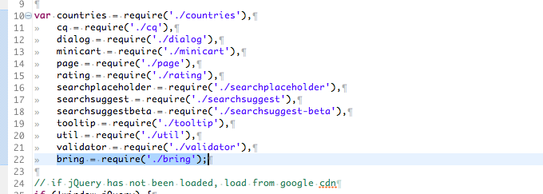

bring.init();

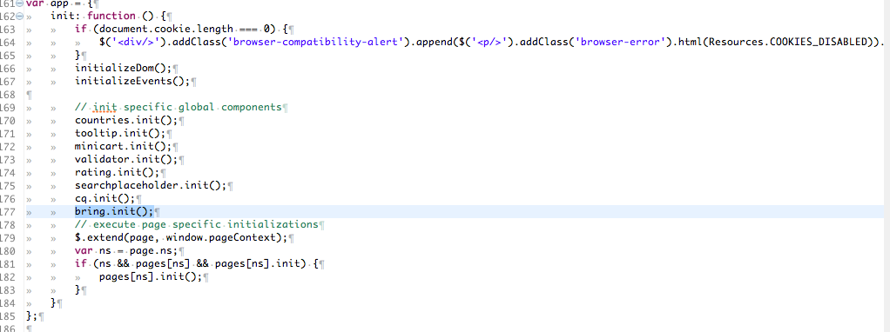

**After making these changes run your JS tool gulp or grunt**

**How to Test:**

1. Add product to cart and reach shipping address page.
2. Enter zipcode/postalcode and focusout of this field.
3. Scroll down to bottom of page and you should see latitude/longitude of a pickup point & below it a button to show it in Google Map

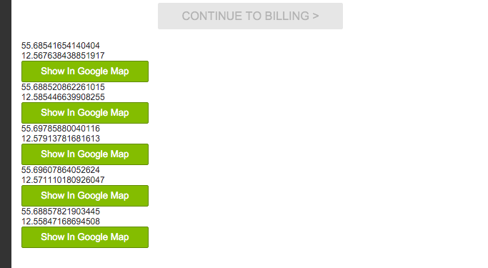

1. Now, click on “Show In Google Map” and you should see

